Physics 3
Question 14
3.1 Medical applications of physics

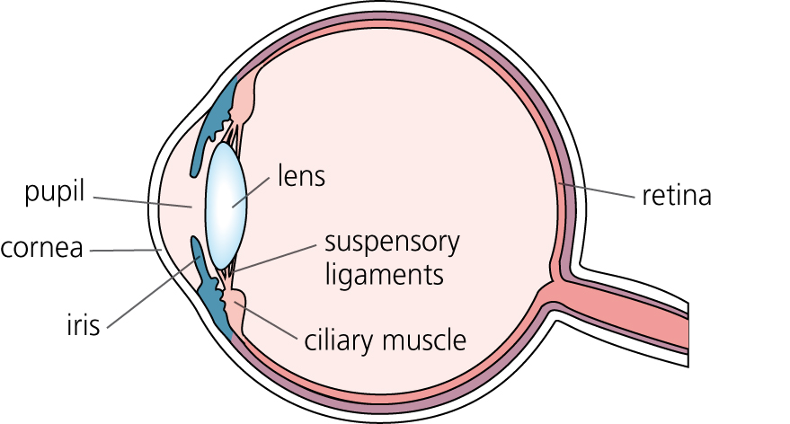
The diagram shows the basic structure of an eye.

(a) Light entering the eye is refracted by the eye lens.
(i) What happens to light rays that are refracted? (1 mark)
(ii) For a person with perfect vision, where in the eye is the light refracted by the eye lens brought to a focus? (1 mark)
(iii) The eye is able to focus on both near and distant objects. Explain how it is able to do this. (4 marks)
(iv) Name the other part of the eye that also refracts light? (1 mark)
(b) A student has poor eyesight and needs to wear a pair of glasses. Each of the lenses used in the glasses has a power of –2.5 D.
(i) Does the student have long sight or short sight?
Give a reason for your answer. (1 mark)
(ii) What eye defect may be causing the student’s poor eyesight? (1 mark)
(iii) Calculate the focal length, in metres, of the lenses used in the glasses.
Write down the equation you need to use and show how you work out your answer. (2 marks)
Question 15
3.1 Medical applications of physics

(a) Ultrasound is a sound wave with a frequency above the upper limit of human hearing. What is the maximum frequency that a person can hear? (1 mark)
(b) What type of wave are X-rays? (1 mark)
(c) Both X-rays and ultrasound are used by doctors to help diagnose illness.
(i) Explain why, before having an X-ray taken, all metal jewellery should be removed. (2 marks)
(ii) Explain why having an X-ray taken is potentially more dangerous than having an ultrasound scan. (2 marks)
(iii) State one advantage of using X-rays to produce an image of part of the human body rather than ultrasound. (1 mark)
(d) A CT scanner uses X-rays to produce detailed images of the human body. The table shows the additional amount of radiation that you are exposed to when having a certain CT scan.

Area of investigation | Additional radiation dose (in arbitrary units)
Abdomen and pelvis | 800
Spine | 600
Head | 200

(i) About 1 in every 4 people develops cancer from natural causes. The additional chance of developing cancer from a CT scan of the head is about 1 in 10 000.
What is the additional chance of developing cancer from a CT scan of the abdomen and pelvis? (2 marks)
(ii) Explain why CT scans are taken even though they increase the chance of developing cancer. (2 marks)
Question 16
3.1 Medical applications of physics

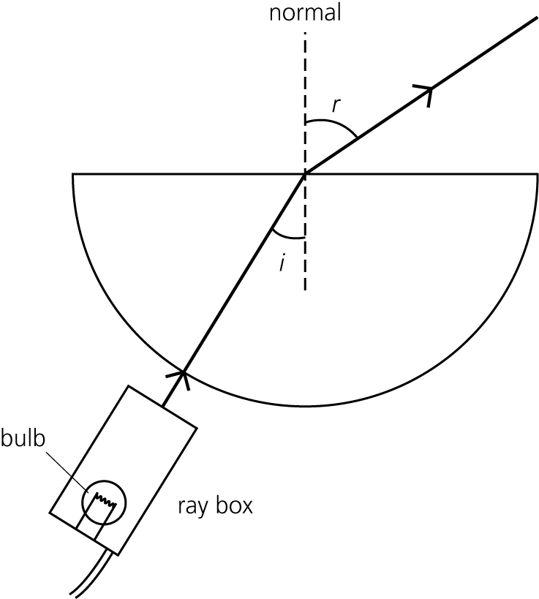
A student investigates the refraction of light as it passes out from a glass block into the air.

Each time the student changes the angle of incidence (i) in the glass block he measures the angle of refraction (r) in the air. The student’s results are given in the table.

Angle of incidence (i) | Angle of refraction (r)
20° | 31°
30° | 49°
42° | 90°
50° | no refracted ray
70° | no refracted ray

(a) (i) What name is given to the angle of incidence that produces an angle of refraction equal to 90°? (1 mark)
(ii) What happens to the light once the angle of incidence exceeds 42°? (1 mark)
(iii) Use data from the table to calculate the refractive index of the glass block.
Write down the equation you need to use and show how you work out your answer. (2 marks)
(b) A doctor may use an endoscope to look directly inside a patient’s body. Explain how an endoscope works. (4 marks)
Question 17
3.1 Medical applications of physics

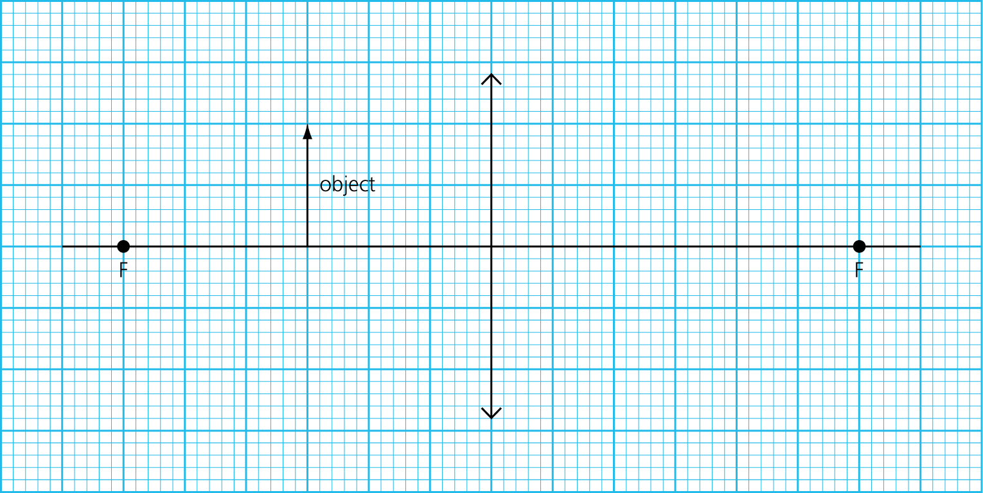
(a) The diagram shows an object 3 cm in front of a converging lens of focal length 6 cm.

(i) Complete a ray diagram to show the position of the image. (4 marks)
(ii) How can you tell from the completed ray diagram that the image formed is virtual? (1 mark)
(iii) Calculate the magnification produced by the lens.
Write down the equation you need to use and show how you work out your answer. (2 marks)
(b) The object is now moved so that it is 8 cm from the lens.
How does the nature of the image change from when the object was 3 cm in front of the lens? (2 marks)
Question 18
3.2 Using physics to make things work

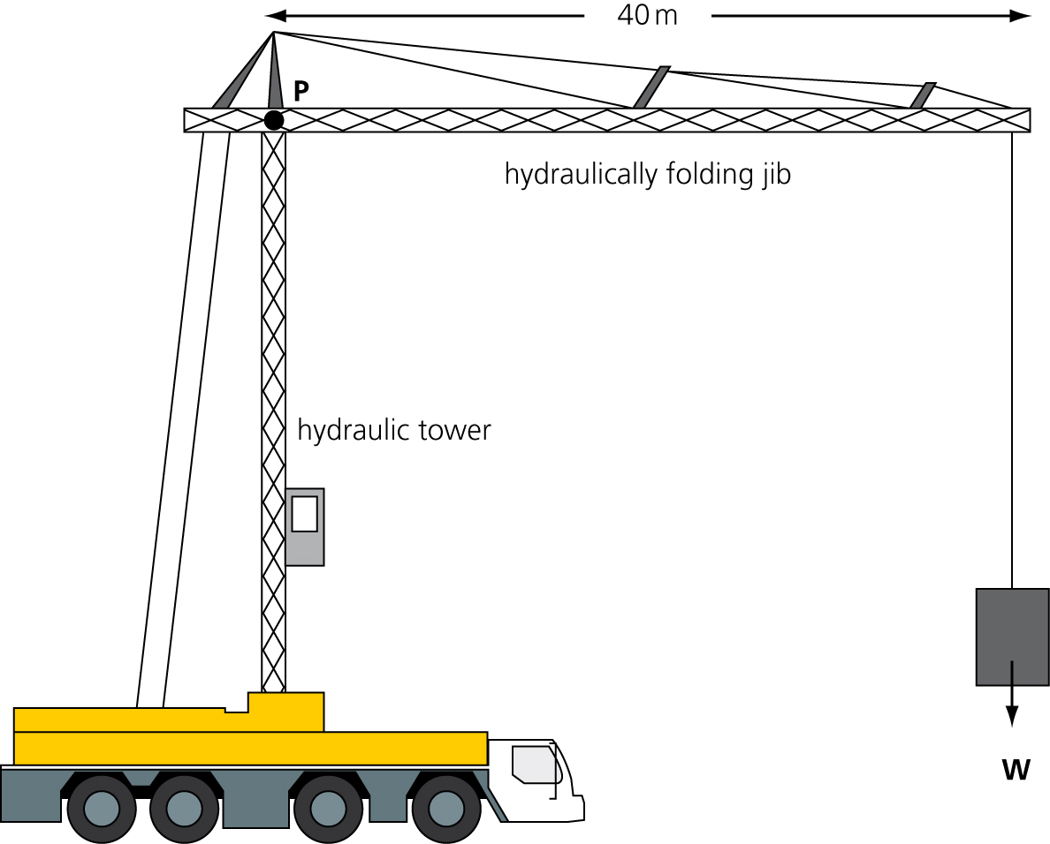
The diagram shows a mobile crane. The tower is raised and lowered hydraulically.

(a) What two properties of a liquid are used by a hydraulic machine? (2 marks)
(b) The clockwise moment about point P, caused by the weight W, is 8 × 10⁶ Nm.
Calculate, in newtons, the size of the weight W.
Write down the equation you need to use and show how you work out your answer. (2 marks)
(c) The maximum weight that the crane can be used to lift is 5 × 10⁵ newtons.
Explain why this maximum weight must not be exceeded. (2 marks)
Question 19
3.2 Using physics to make things work

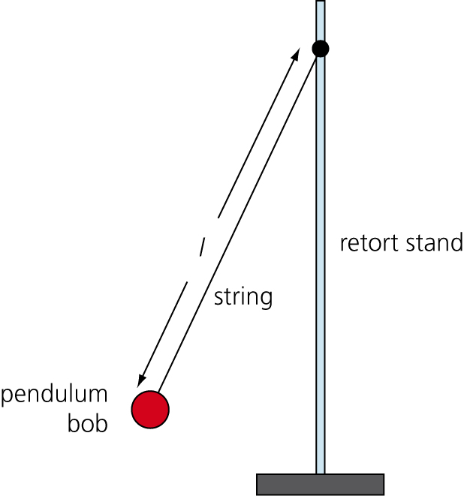
(a) The diagram shows a simple pendulum at one point in an oscillation (swing).

(i) Draw a cross (×) on the diagram so that the centre of the cross marks the position of the centre of mass of the pendulum bob. (1 mark)
(ii) Draw a circle on the diagram to show the position of the pendulum bob once the pendulum stops swinging.
Give a reason for your choice of position. (2 marks)
(b) A student has written the following hypothesis.
‘The frequency of a simple pendulum is inversely proportional to the length of the pendulum.’
If this hypothesis is correct, what would happen to the frequency of a pendulum each time the length is doubled? (1 mark)
(c) The student investigated the hypothesis by timing 10 swings of a pendulum. The student repeated this for several different lengths. The student’s experimental data and calculated data are recorded in the table.

Length of pendulum in metres | Time for 10 swings in seconds | Frequency in _____
0.25 | 10 | 1.0
0.50 | 14 | 0.7
0.75 | 17 | 0.6
1.00 | 20 | 0.5
1.25 | 22

(i) What is the unit of frequency? (1 mark)
(ii) Calculate the frequency of the pendulum when the length equals 1.25 m.
Write down the equation you need to use and show how you work out your answer. (3 marks)
(iii) Do the data in the table support the student’s hypothesis?
Support your answer with a calculation. (1 mark)
Question 20
3.3 Keeping things moving

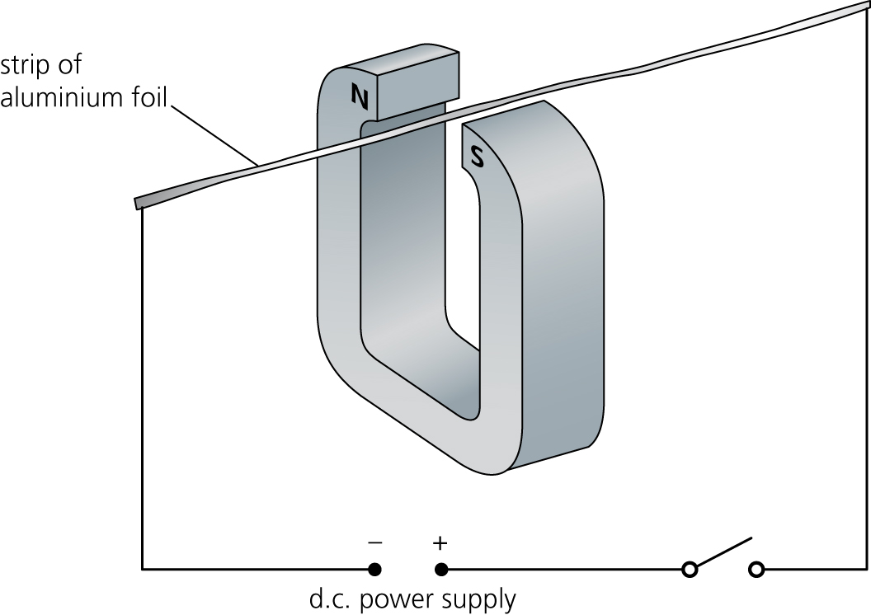
Diagram 1 shows a thin strip of aluminium foil held between the poles of a strong magnet.
Diagram 1
(a) When the switch is closed the aluminium foil moves. Explain why. (3 marks)
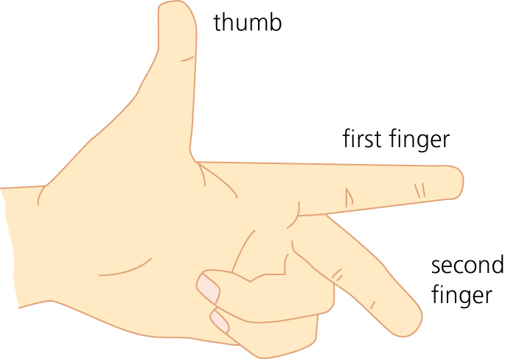
(b) The direction in which the wire moves can be predicted using Fleming’s left-hand rule.
Diagram 2
(i) When Fleming’s left-hand rule is used, what does each of the following represent?
1 the thumb
2 the first finger
3 the second finger (2 marks)
(ii) In which direction will the aluminium strip in diagram 1 move when the switch is closed? (1 mark)
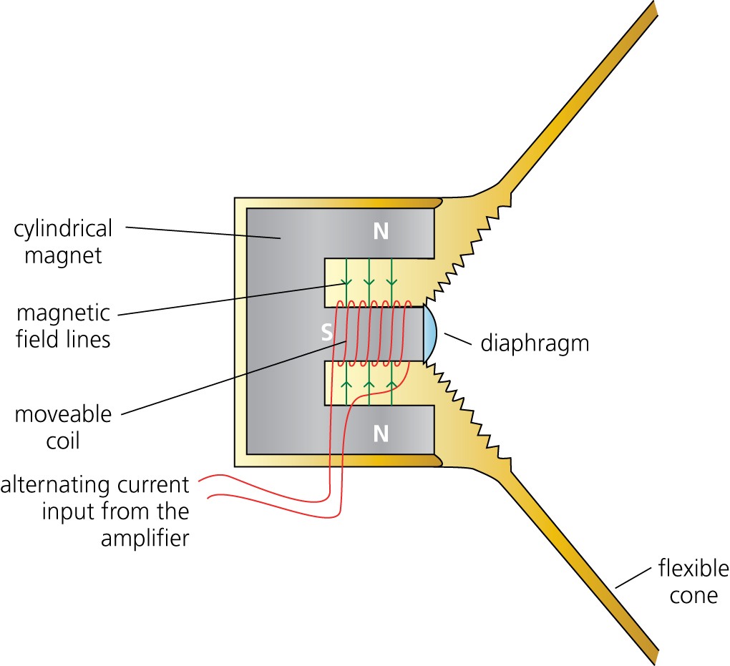
(c) Diagram 3 shows the cross-section through a loudspeaker.
Diagram 3
Explain how the alternating current input from the amplifier causes the loudspeaker cone to vibrate. (5 marks)
Answer 14
(a) (i) The light rays change direction. 
Change direction is sufficient for the mark
(ii) At the retina 
Remember that the retina is where the image in the eye is formed.
(iii) To focus on near objects the ciliary muscle contracts, making the suspensory ligaments slack.  The eye lens becomes fatter  and more powerful.
To focus on distant objects the ciliary muscle relaxes  and the suspensory ligaments pull the lens, making it thinner  and less powerful.
The question is really asking two things: first about being able to focus on near objects and second about being able to focus on distant objects. This answer is clear to follow and keeps the explanation for near objects separate from that for distant objects. The key point in each part of the answer is the effect of the ciliary muscle and suspensory ligaments on the shape of the eye lens.
(iv) Cornea 
It is easy to forget that the cornea also plays an important part in the refraction and focusing of light in the eye.
(b) (i) Short sight. Diverging lenses used to correct short sight have a negative power. 
There is no mark for simply stating short sight. The key to this question is remembering the type of lenses that have a negative power and then relating this to the correction of short sight.
(ii) The eyeball may be longer than it would be for normal sight. 
The other possible cause of short sight that you need to remember is the inability of the eye lens to focus.
(iii)  = 0.4 m 
This is clearly set out with substitution shown. Remember that no substitution and a slip with the calculator would mean no marks.
Answer 15
(a) 20 000 Hz 
Although this question only asked for the upper limit of human hearing you need to remember that the complete range goes from 20 Hz to 20 000 Hz.
(b) Electromagnetic waves 
X-rays are at the high-frequency end of the electromagnetic spectrum.
(c) (i) X-rays are absorbed by metals  and if not removed the jewellery would show up on the X-ray .
When a question asks you to ‘explain’, the points that you make should be linked. An alternative to the second point given here would be ‘if the jewellery were not removed its image could block out important detail’.
(ii) X-rays are a form of ionising radiation, whereas ultrasound is non-ionising. 
Ionising radiation like X-rays can damage or even kill healthy body cells. 
This question asks for a comparison and so it is important that both X-rays and ultrasound are mentioned.
(iii) The images from X-rays are much more detailed. 
This is really the only advantage of X-rays over ultrasound that you need to remember.
(d) (i) 
so 1 in 2500 
The calculation has been clearly set out. It would have been easy to make a slip and multiply the 10 000 by 4 to end up with an incorrect answer of 1 in 40 000. However, had this been done, hopefully it would have been realised that this figure suggests a lower risk, whereas the data in the table clearly indicate a greater risk.
(ii) The benefit of a CT scan in being able to help diagnose a serious illness  is far greater than the additional risk of developing cancer due to the scan. 
The two points have been clearly linked.
Answer 16
(a) (i) Critical angle 
This is the only correct answer.
(ii) The light is totally internally reflected. 
It would be insufficient to simply say that ‘the light is reflected’ or even ‘reflected back into the block’.
(iii)  
Alternatively the equation refractive index = sin i/sin r could have been used. However, if you use this equation you must imagine the light to be travelling from air into glass and not the other way around. So take the angle of incidence as either 31° or 49° with the associated angle of refraction either 20° or 30°.
(b)
- An endoscope has two bundles of optical fibres. 
- Light that is directed into one bundle travels from one end to the other by being totally internally reflected many times. 
- The light is then reflected back through the second bundle of optical fibres. 
- The image is viewed through a lens,  or if a miniature camera is attached to the optical fibres the image can be displayed on a computer screen.
It is perfectly okay to answer a ‘prose’ type question using bullet points. However, if you do, make sure each bullet point is a complete sentence.
Answer 17
(a) (i)
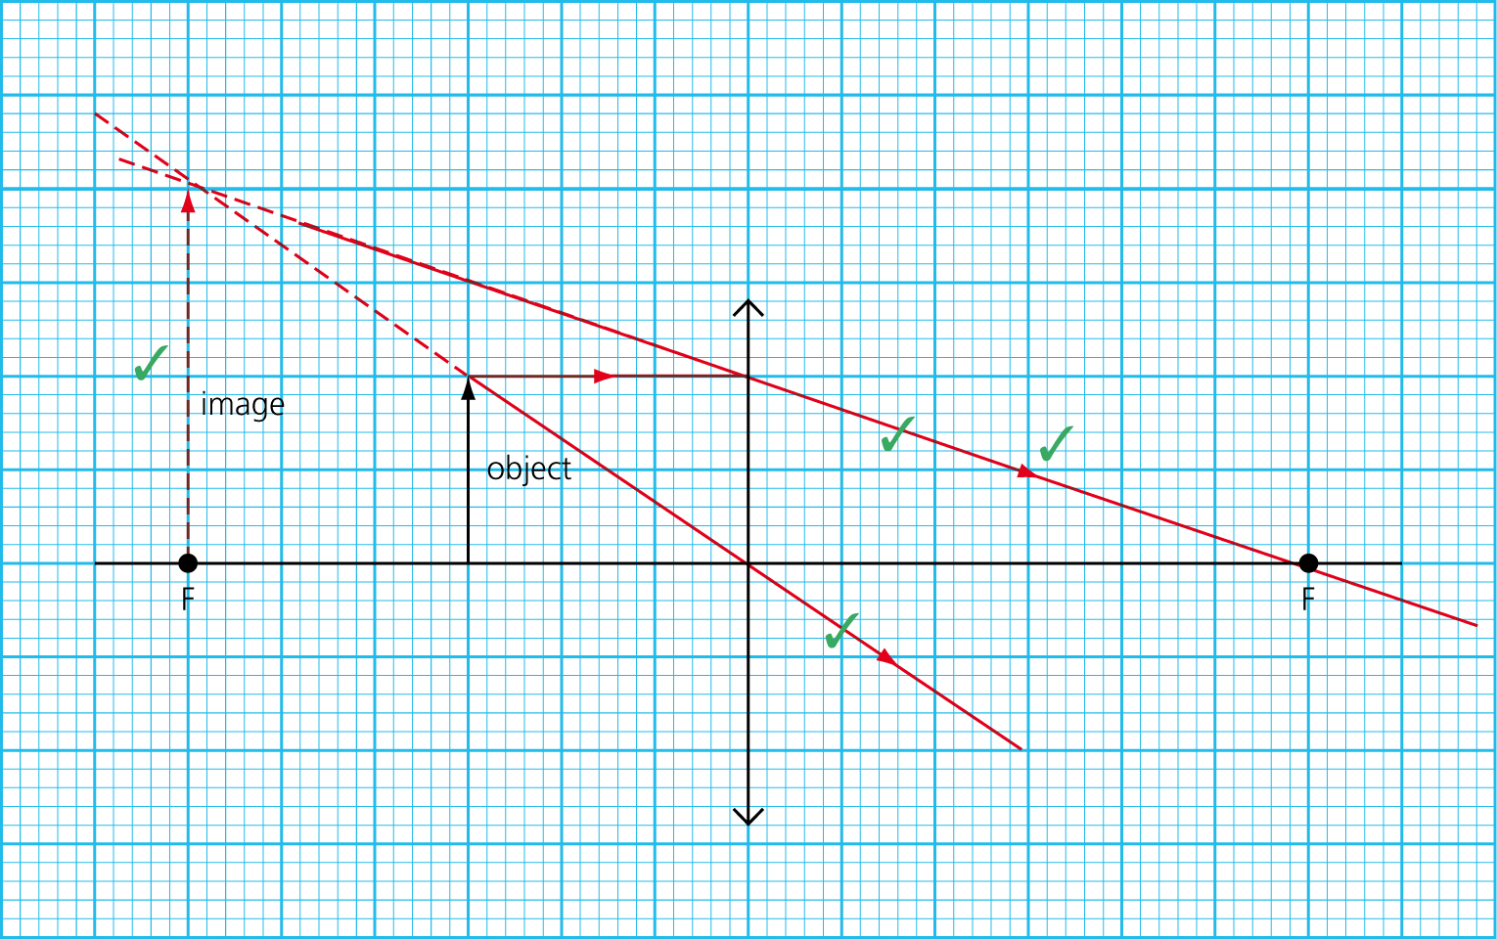
By using a ruler the final diagram is more likely to be accurate than if drawn freehand. When adding arrows to the lines that represent rays of light make sure that they go in the correct direction and that there are no contradictory arrows. Like the object, the image should always touch the principal axis.
(ii) The image is on the same side of the lens as the object. 
This answer is specific. Statements such as ‘in front of the lens’ or ‘behind the lens’ are ambiguous as both statements could refer to either side. Answers such as ‘dashed lines have been used’ do not tell us anything about the image and would not get the mark.
(iii) cm  = 2 
It may be difficult to be totally accurate in drawing a ray diagram so a tolerance will be allowed in the magnification value. In this case an answer between 1.8 and 2.2 may be acceptable.
(b) The image changes from being virtual and upright to being real and inverted. 
Two changes have been given; each is worth a mark. The image is still magnified, so this is not a change and therefore should not be mentioned. In order to get this answer you may need to draw another ray diagram. But this time it can just be a quick sketch, as no marks are allocated for producing one.
Answer 18
(a) 1 Liquids are virtually incompressible. 
2 Pressure is transmitted equally in all directions throughout a liquid. 
Both of the properties have been expressed clearly and concisely. In the first answer if the word ‘virtually’ had been omitted the mark would still have been given. If you forget the word ‘incompressible’ you could say ‘cannot be squashed’.
(b)  = 2 × 10⁵ N 
Some of the data have been given in standard form. You can leave them like this and give an answer in standard form or rewrite 8 × 10⁶ as 8 000 000 and give the answer as 200 000 N. However, for some questions, mainly those involving very big or very small numbers, you should understand and be able to use standard form.
(c) If the maximum weight were exceeded the moments would no longer balance.  The resultant moment would cause the crane to topple. 
Although it is not clear if it is the whole crane or just the jib that would topple, the marks have been given for the idea that a resultant moment will cause something to rotate.
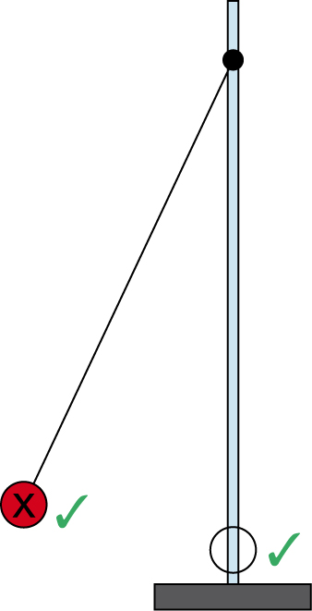
Answer 19
(a) (i) and (ii)

A suspended object will always stop so that its centre of mass is directly below the point of suspension. 
The pendulum bob is a symmetrical object and so the centre of mass must be on an axis of symmetry. For a circle it will always be at the centre of the circle. The position of the stationary pendulum bob is clearly marked and supported with a well-explained reason.
(b) The frequency would halve. 
Inversely proportional means more than simply ‘as one quantity increases the other quantity decreases’. If two quantities are inversely proportional, when one doubles the other will halve.
(c) (i) Hertz 
This could also have been given in symbol form (Hz). However, if you use symbols make sure they are correct. Hz gets a mark but hz would not.
(ii) time period, T = 22 ÷ 10 = 2.2 s 
 = 0.45 Hz 
The other values for frequency have been rounded to one decimal place so it would be okay to round this answer to 0.5.
(iii) No it does not support the hypothesis. If the hypothesis were correct then doubling the length from 0.5 m to 1.0 m should make the frequency go from 0.7 Hz to 0.35 Hz  and it does not.
Marks are not awarded for simply saying yes or no. In this case 1 mark is given for a relevant calculation supporting the ‘no’. The answer could equally have used the example of doubling the length from 0.25 m to 0.50 m.
Answer 20
(a) When the switch is closed the circuit is complete and a current flows through the aluminium foil.  The current produces a magnetic field around the aluminium foil. 
This magnetic field interacts with the field of the magnet, causing a force to act on the aluminium foil. 
The answer is given in a logical sequence, starting with closing the switch and ending with the effect on the foil.
(b) (i) thumb = direction of the force
first finger = direction of the magnetic field from north to south
second finger = direction of the current 
You could also say that the thumb represents the direction of motion.
(ii) Upwards 
This could have been a lucky guess, but hopefully it means that Fleming’s left-hand rule is understood and has been applied correctly. Remember that with Fleming’s left-hand rule the direction of the current is the direction of conventional current, i.e. from + to –.
(c) The current passing through the coil is always at right angles to the magnetic field lines.  So depending on the direction of the current there will be a force either forwards or backwards on the coil.  With an alternating input the direction of the force will reverse every time the current changes direction.  This will cause the coil to vibrate.  Since the coil is joined to the loudspeaker cone, when the coil vibrates so will the cone. 
A clear sequence has been given, with each mark point linked to the previous one. You could have written each of these sentences as bullet points, but remember that if you use bullet points make sure each is a complete sentence and not just two or three words.

