My Revision Notes WJEC B GCSE Geography
Answer guidance for Exam Practice questions

Page 26

- 16685. Don’t estimate, give an accurate answer.

- This question asks for an explanation of one effect and offers two marks. You will need to give a simple statement followed by its elaboration. It could be a positive or negative effect.
For example, a positive effect could be ‘Many experienced shop assistants out of work (1) so the company may employ ready trained staff (1)’.
However, a negative multiplier effect could be ‘Local people have less disposable income (1) so company sales will be reduced (1)’.

- This asking only for three effects taken from the text. Don’t elaborate them.
Three reasons you may quote would include competition from the internet, less demand for cameras because of photo function on mobile phones and high value items being bought less frequently.

- Four marks are offered for two effects so each must have a simple statement and elaboration as in (b) above.
Advantage example: ‘Usually cheaper (1) so the customer will save money (1)’.
Disadvantage example: ‘Can’t handle, try on or see the product working (1) so it may prove unsuitable (1)’.

Page 30

- A simple statement of ‘Gauteng’ is sufficient.

- There are three marks on offer so you will need to make three separate statements that show you have analysed the map evidence.

The overarching pattern is one of a decrease in numbers of migrants with distance from Limpopo. Backing this up with reference to actual figures for Gauteng and Eastern Cape will gain your second mark. You will earn the third mark by referring to an exception to the general pattern; that of Northern Cape. It is not the furthest province from Limpopo but attracts the smallest number of migrants.

Page 33

- Describing a trend on a graph is similar to describing a pattern on a map.

In this case the percentage trend in people living in slums is decreasing (1) steadily (1). The first two marks are already earned. The question asks you to use figures in your answer. This is good practice whether or not the question asks you to do so. Quote the percentages for 1990 and 2010.

- The numbers of people living in slums shows the opposite trend. It is increasing (1) steadily (1). Adding the figures will enhance your response.

C. This five mark question will be marked using a ‘levels of response’ mark scheme.

In the lowest level you will make simple statements; build houses, build schools, improve water supplies and sanitation. To get into the second level you will elaborate the simple statements; houses to provide shelter, schools to improve education opportunities, water and sanitation to reduce disease. In the highest level you will have to give specific information. For example, by quoting a disease, like cholera, that improved sanitation will protect against or by quoting actual places where slum dwelling improvements have been made by a city’s authorities.

Page 43

  - The first mark is for stating that there is a strong correlation between the two. A second would be for quoting an example of where there are large numbers of holiday homes close to a National Park, for example, the Lake District and Snowdonia National Parks.
The last two marks are for giving exceptions to the general trend. One for National Parks that don’t have the highest numbers of holiday homes nearby, for example, the Brecon Beacons, and the other for an area of high numbers of holiday homes that are not close to a National Park. For example, Dorset.

  - Each reason here must comprise a simple statement and its elaboration.
Examples could include: ‘National Parks are areas of natural beauty (1) so attract holiday visitors (1)’ or ‘Not all areas of natural beauty are National Parks (1) but still attract large numbers of holiday visitors.’

Page 47

    - You will need to make three separate statements to be credited with the full three marks for this question.
Describing its north-westerly direction across the ocean to 29 April as a tropical storm will earn your first mark. Its change of direction to north-easterly as a hurricane force storm gets the second. It’s landfall on 2/3 May will complete the three marks.

    - This question will be marked using a ‘levels of response’ mark scheme having three levels.
The levels will rise from ‘only description’ to ‘explanation’ to ‘explanation containing specific detail’. So to get into the highest level you will need to produce statements like, ‘800 000 homes being damaged made people homeless and unable to shelter from the effects of the weather. They would be likely to live in unsanitary conditions and suffer the effects of water-borne diseases like cholera and typhoid.’
This could be linked to another effect shown on Figure 3, such as, ‘three quarters of health services were damaged, meaning that people injured by the storm could not be treated and medicines were unavailable for treatment of the effects of diseases like typhoid and cholera‘. Don’t be tempted to merely copy the evidence from Figure 3 without fully explaining it.

Page 48

Higher Tier

      - You should be used to patterns by now. Refer to months when describing the trend, giving figure for the lowest and highest ‘actual rainfall’. Use terms like ‘rising/falling steeply’ and ‘fluctuating’. Looking at the Foundation Tier passage may help you.

      - You will quote the general actual precipitation as being between 20 and 30mm lower than average for all bar two months. Also the large increase over average in especially August when the difference is 130mm.

      - The key to this question lies in recognising that, apart from two months, August and October, precipitation is lower than the amounts the people are used to receiving. The response given for the Foundation Tier question may then be used (see below).

Foundation Tier

        - July (1), 87 (1), November (1), 63 (1), 158.

        - It is possible to quote evidence from Figure 5b but each piece of evidence from here will need to have an elaboration that explains the effect on quality of life.
Examples include, ‘no watering of gardens (1) so people would lose money by having to buy food to replace home-grown vegetables that die (1) and ‘no filling of private swimming pools (1) so there would be increased costs of time and money in travelling to the public pool (1).

Page 54

Include the general pattern, named continents and an exception to the pattern.
Thus: The rainforests are distributed almost solely within the tropics (1) in Latin America, Africa and Asia (1). However, some areas stretch outside the tropics as in southern Madagascar (1)

Page 55

          - 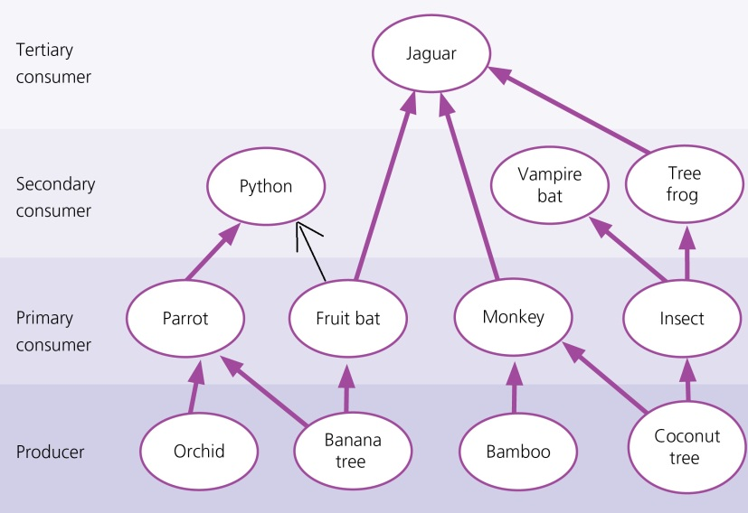

          - You have many choices here and may quote elements from producer to secondary consumer or from primary consumer to tertiary consumer. It is important, though, to actually name the species involved, for example, ‘orchid > parrot > python’.

  - You will be expected here to produce a continuum involving four elements, as the question has four marks. Thus, one possible route through would be:
‘There will be a reduction of food for the jaguar and they will eat more tree frogs (1). This will place greater pressure on tree frogs whose numbers will reduce (1). Insect populations will therefore increase providing more food for vampire bats (1) whose numbers will increase (1)’.

Page 62

          - Make sure you do this accurately using a ruler!

    - May (1), 21000 (1), rapidly (1).

- The key to this answer is found in the flow diagram. You must mention a combination of periods of heavy rainfall brought about especially during the cyclone season, snow melt higher in the catchment and the effects of high tidal flows from the sea.

Page 66

As you can see from Figure 22, Option 2 was chosen. Is that the one you would have chosen? If so, put together a report no longer than one page of A4 paper in which you:

- First look at Option 1, recognise some of the advantages of having chosen this option but elaborate in as great detail as possible the disadvantages of choosing this strategy.
- Now recognise the disadvantages of choosing Option 2 but elaborate in great detail the advantages of this strategy.

If you chose Option 1 adapt the sequence above to suite your choice.

Whichever you chose, ensure that you write about the decision in terms of its short and longer term sustainability for the residents of Attenborough and their homes and for the natural environment.
Bring into your argument any knowledge you have from case studies in school, have read or perhaps seen on television that help to support the decision you have made.

Page 78

  - 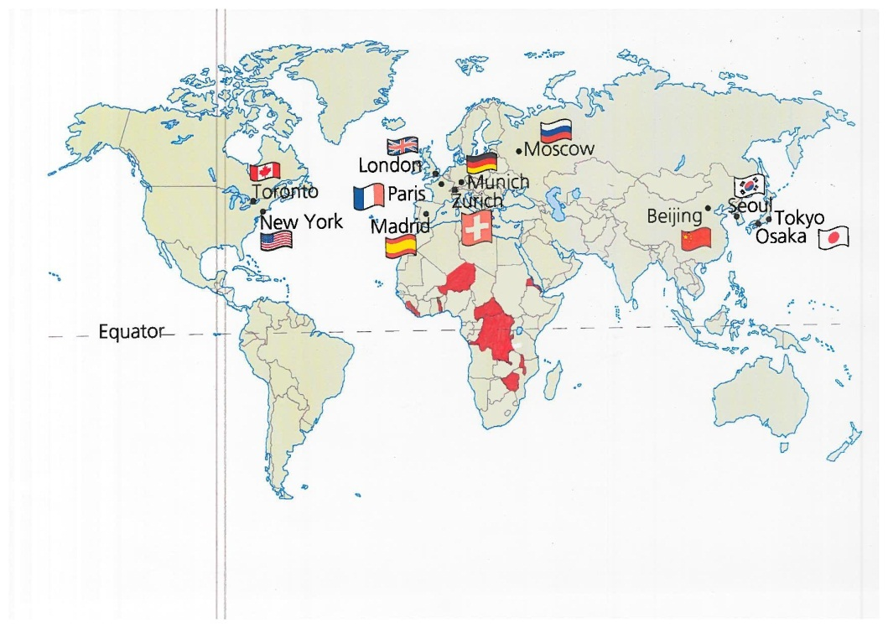

  - Your answer should not be merely a list. You should refer to traditionally richer countries like Japan, the UK and USA and also Newly Industrialised Country (NIC), China, and a former communist country, Russia. The question asks you to use figures. All of the countries on the map have just one city represented apart from Japan, which has two.

Page 95

    - The first thing to note is that the pattern fluctuates between surplus and deficit. You must then identify the greatest surplus in 2004 at 270000 tonnes and the lowest deficit in 2007 at 320000 tonnes.

    - A six mark question will be marked using a ‘levels of response mark scheme’. You will only get into the highest level by quoting specific detail. So, it’s no good to make vague statements. A surplus will mean that there is more being produced than is needed so the price will fall. This will make the farmers poorer and they will not be able to afford the basic necessities of life thus endangering the health of both themselves and their families. This results also in mental strain. In times of deficit, there is more demand than supply so the price rises. It is likely that in these years the farmers will be able to support their families.
One of the greatest problems is the uncertainty experienced by the farmers. If they are unable to predict their year on year earnings they will not be able to commit to such ongoing expenses as the education of their children.

Page 97

In this brief practice task, you need to decide first which aid programme meets the views of the two people concerned. It should be clear that the programme located in Mali is most likely to meet the views of Ibrahima Coulibaly, while that located in Tanzania is the programme that would be supported by Mokombo Swaminathan.
However, as you should know by now, there are no correct answers to the final task on your problem solving paper (Unit 2B). It is the argument that you use to justify the decision you have made that will be rewarded. So, which scheme do you feel is the most appropriate route to sustainable development in an economically poor African country?
Adapt the strategy described in the answer to page 66, above, to help you write a brief report expressing your views on the issue

